# **AzureML RRS: Visual Studio Template for ASP.NET web app generation**

# Install the Visual Studio Template

1. Download zipped template file to your local drive (don’t unzip!).(don’t unzip!).
2. Copy it to your Visual Studio templates directory: e.g. *C:\Users\<username>\Documents\Visual Studio 2013\Templates\ProjectTemplates*
3. Start Visual Studio 2013 (the version you installed the template for)
   1. **Click File -> New-> Project**
   2. Select **AzureML RRS Web Template**. Click **OK**.

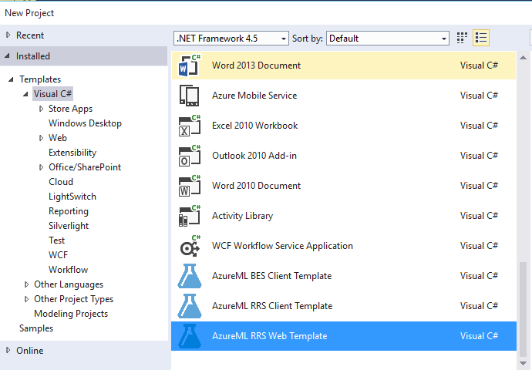

# Run the app to set up the page

1. Run the app. (Press **F5**)
2. On the setting.aspx page, enter the **AzureML API URL and Key**. (You can get this information from the AzureML Studio's API Dashboard and RRS Help page.) Then press **Submit**.

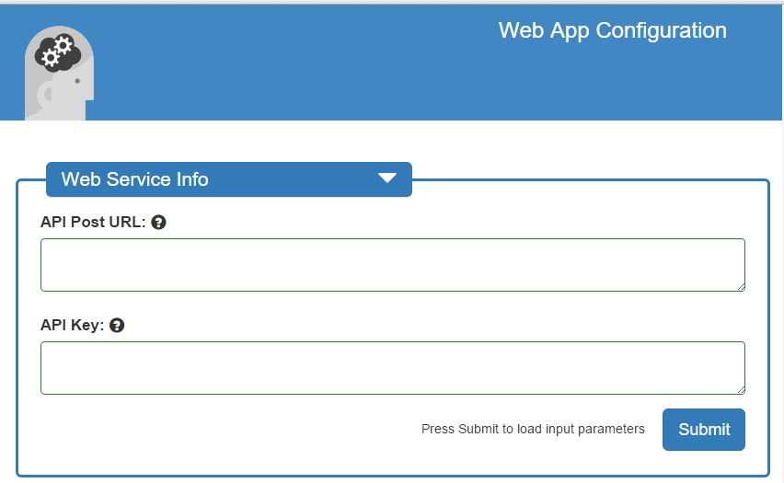

1. After the parameters are read and generated on the page, you can enter default values, alias for column names, and data ranges.

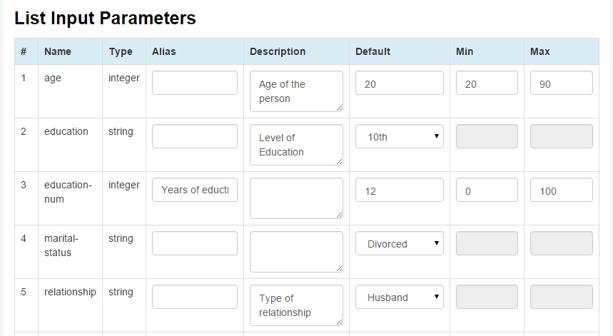

* 1. You can also decide what not to include in output.

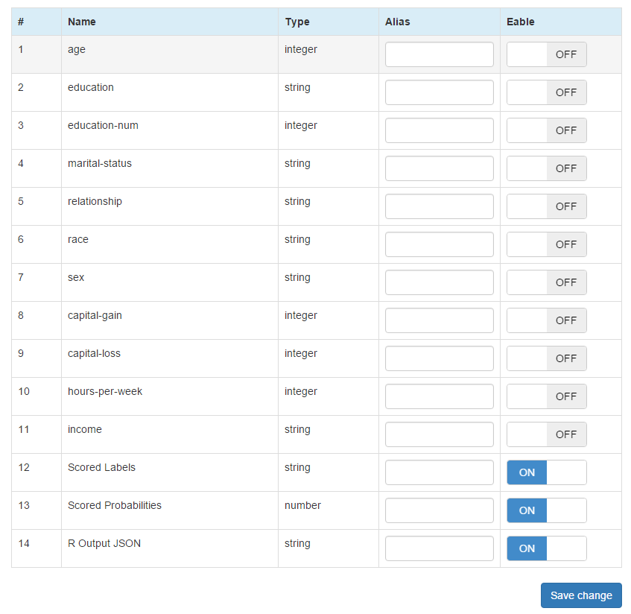

1. Click to **Save Changes**. The page will update with the ranges and default values.

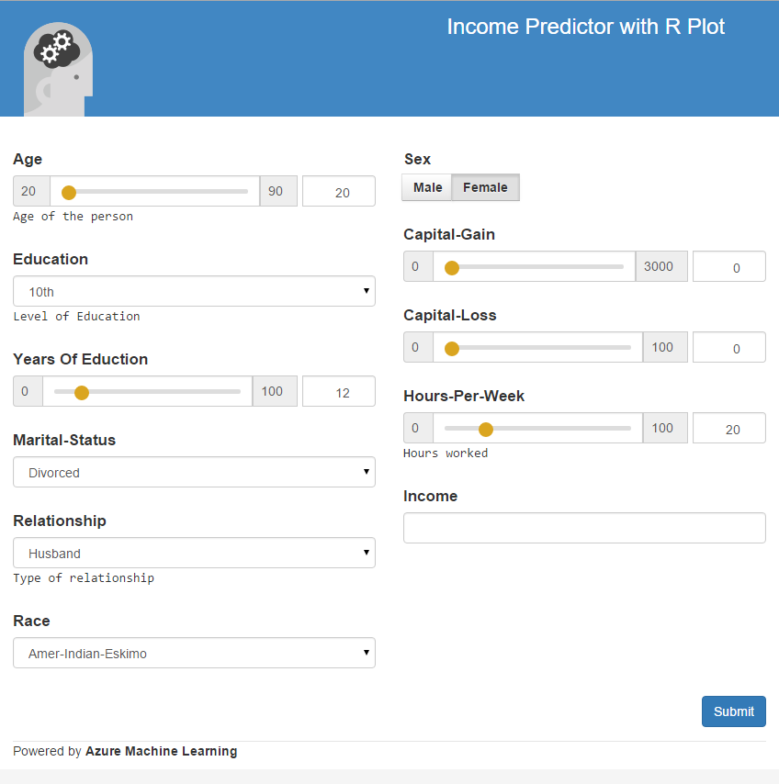

h. After submitting, the result is shown including any plots.

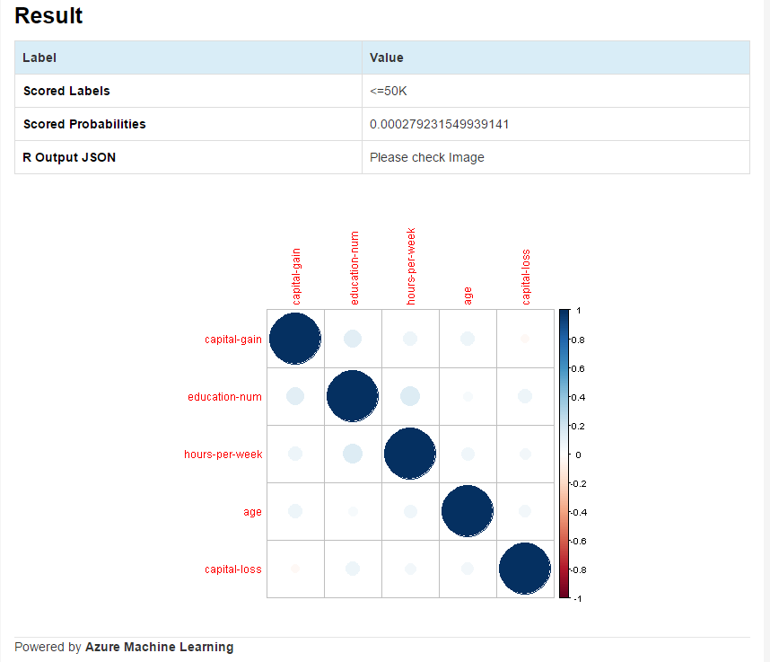

# Updating app settings

You can update the settings by going to \**settings.aspx** page.

* You will be prompted to enter the web service **API key** to access the page.
* Update and save the settings.
* The Default.aspx page will show the resulting changes.